CREATE DATABASE MachineTest

USE MachineTest

--Creating Table Employee (Parent)

CREATE TABLE Employee

([1]

EmployeeID INT PRIMARY KEY IDENTITY,

EmpName VARCHAR(30),

Phone VARCHAR (10),

EmailID VARCHAR(30)

)

--Creating Table Manufacture (Parent)

CREATE TABLE Manufacturer

(

MfName VARCHAR(20) PRIMARY KEY,

City VARCHAR(20),

State VARCHAR(20)

)

--Creating Table Computer (Child)

CREATE TABLE Computer

(

SerialNumber INT PRIMARY KEY IDENTITY,

MfName VARCHAR(20)

CONSTRAINT fk_MfName

FOREIGN KEY(MfName)

REFERENCES Manufacturer(MfName),

Model VARCHAR(20),

Weight NUMERIC(7,2),

EmployeeID INT

CONSTRAINT fk_EmployeeID

FOREIGN KEY(EmployeeID)

REFERENCES Employee(EmployeeID)

)

--Inserting records in Employee Table

INSERT INTO Employee (EmpName,Phone,EmailID) VALUES

('Name 1','1234567890','abc@pqr.com'),

('Name 2','3456342312','xyz@fdf.com'),

('Name 3','2345346789','jhg@gds.com'),

('Name 4','8956342345','wdd@fg.com'),

('Name 5','7865865658','iuy@rwer.com'),

('Name 6','9897767678','sa@fefr.com'),

('Name 7','6785687579','dwa@wq.com'),

('Name 8','6546764654','hed@grf.com'),

('Name 9','9898767687','yre@gd.com')

--Inserting records in Manufacturer Table

INSERT INTO Manufacturer VALUES

('Mf1','Trivandrum','Kerala'),

('Lenovo','Charity','South Dakota'),

('IBM','Seattle','Washington'),

('Acer','Pierre','South Dakota'),

('Apple','Buffalo','New York'),

('Dell','Dallas','Texas')

--Inserting records in Computer Table

INSERT INTO Computer (MfName,Model,Weight,EmployeeID) VALUES

('Apple','Model 1',62.70,1),

('Mf1','M-123',56.45,9),

('Lenovo','L-787',34,4),

('Acer','A-34',23.56,3),

('IBM','I-676',23.65,5),

('Acer','A-878',10.2,6),

('Dell','D-56',12.4,8)

SELECT * FROM Employee

SELECT*FROM Manufacturer

SELECT*FROM Computer

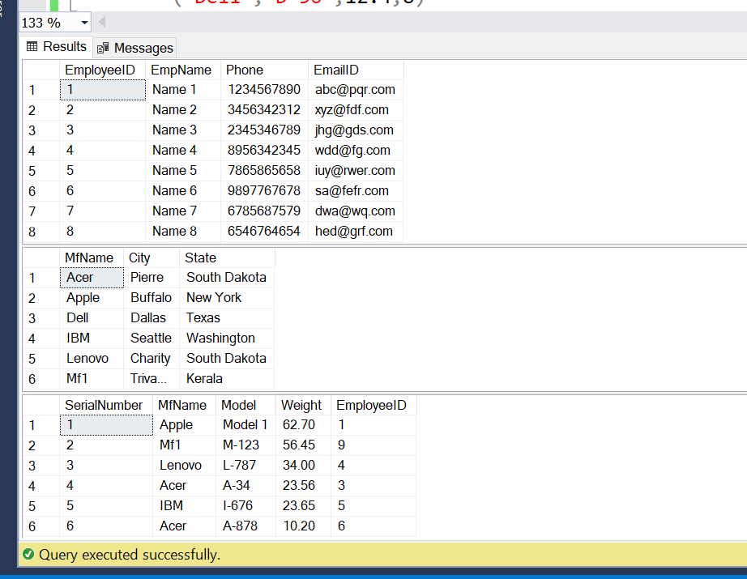

--SQL Statements Solution

--Solution 1

SELECT MfName AS [Manufacture Names] FROM Manufacturer

WHERE State LIKE 'South Dakota'

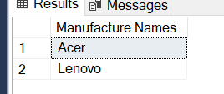

--Solution 2

SELECT AVG(Weight) AS [Average Weight] FROM Computer

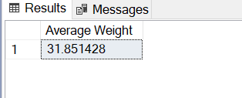

--Solution 3

SELECT EmpName FROM Employee

WHERE Phone LIKE '2%'

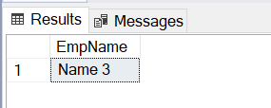

--Solution 4

SELECT SerialNumber AS [ComputerWeighBelowAvg] FROM Computer

WHERE Weight < (SELECT AVG(Weight) FROM Computer)

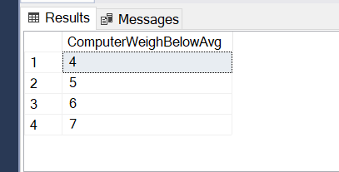

--Solution 5

SELECT MfName FROM Manufacturer

WHERE MfName NOT IN (SELECT DISTINCT MfName FROM Computer)

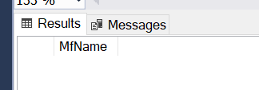

--Solution 6

SELECT EmpName, SerialNumber, City

FROM Employee e

INNER JOIN Computer c

ON e.EmployeeID = c.EmployeeID

INNER JOIN Manufacturer m

ON m.MfName = c.MfName

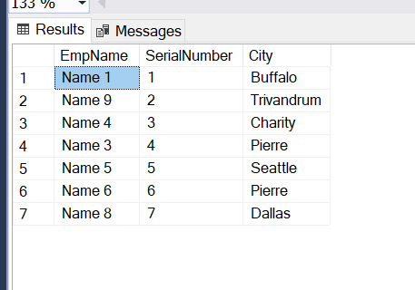

---Solution 7

CREATE PROCEDURE sp_EmployeeDetails

@EmployeeID INT

AS

BEGIN

SELECT SerialNumber, MfName, Model, Weight

FROM Computer

WHERE EmployeeID = @EmployeeID

END

EXEC sp_EmployeeDetails 3

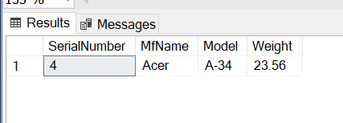

1.